

|  |  |  |  |
| --- | --- | --- | --- |
| Academic Year | 2023 | | |
| Semester | Fall | Winter | Summer |
| Course Code - Name | WEB 422 - Web Programming for Apps and Services | | |
| Instructor | Dr. Razi Iqbal | | |
| Assessment | Assignment 1 |  | |
| Deadline | Sunday, October 15, 2023 | | |

**Student ID 127930212**

**Student Name Sangin(Jenny) Lee**

**Assignment 1**

The main purpose of this assignment is to test your knowledge of Bootstrap and basics of React frameworks. This assignment assumes that you have already setup your environment.

**Instructions:**

* This assignment is 10% of your total marks in this course.
* Please use this document to provide your answers. Scroll down to the Solution section and paste your code for each component in that section. Do not forget to provide the screenshot of your final output. Upload this word document on Blackboard as the submission.
* Images required for this assignment are made available to you on Blackboard under Assignments folder.
* Submissions through emails will not be accepted.
* Students having exactly similar code will get a straight 0.
* The deadline for submission of this assignment is midnight Sunday, October 15, 2023.

**Question**

In this assignment, you are required to create a portal for a recruitment agency that provides employers a hub for hiring talents throughout the world. Assuming various talents and employers have already subscribed to the portal, you are designing a page from the perspective of an employer who has signed in to the portal to hire a new talent.

This assignment has 4 sections. Each section requires you to complete a component with all of its requirements fulfilled. You are required to use Bootstrap and React to complete these sections. Make sure you keep each component in their separate module, e.g., NavBar.js etc. which are then called in index.js.

**Section 1:**

In this section, you are expected to create a NavBar. Please note the following:

* Use Bootstrap’s NavBar to design it
* NavBar should have at least the following components:
  + A logo on the left side of the bar
  + A title next to the logo
  + Menu items in the center of the bar
  + Input box and a Search button to the right of the bar
* You are most welcome to take the code from Bootstrap
* Below is the expected output of this NavBar:



**Section 2:**

In this section, you are expected to create a Welcome Card. Please note the following:

* Use Bootstrap’s Card to design it
* This main card should have a white background and 4 cards within it
  + Card 1: A white background with a heading and a welcome message. Use appropriate heading and text
  + Card 2, 3, 4: Different light backgrounds with a heading, some text and a button.
  + For these 4 inner cards, make sure you reuse the components instead of copy pasting and duplicating the code. props can help you in doing that. *Failing to reuse the components might result in losing the marks.*
* Below is the expected output of this Welcome Card:



**Section 3:**

In this section, you are expected to create a Talent’s Card. Please note the following for each Talent’s Card:

* Similar to Section 2, use Bootstrap’s Card to design it
* The card should have a light green background with 5 components to it
  + A photo (should be a circular image).
  + Text (name of the talent in bold format)
  + Text (job title with a slightly smaller text)
  + Text (hourly rate with text size slightly bigger than job title)
  + A row of four icons
* Below is expected output of this card

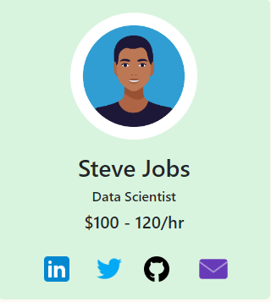

**Section 4:**

In this section, you have to reuse the Talent’s Card you created in Section 3 to generate 5 Talent’s Cards. One of the approaches would be to place them in a row. Please note the followings:

* For these Talent cards, make sure you reuse the components instead of copy pasting and duplicating the code for 5 cards. props can help you in doing that. *Failing to reuse the components might result in losing the marks.*
* Use the following data to provide to the Talent Cards. Iterate through these arrays and populate your Talent Cards.

const names = ["Steve Jobs", "Bill Gates", "Jeff Bezos", "Elon Musk", "Warren Buffet"];

const jobs = ["Data Scientist", "ML Engineer", "Front End Developer", "Java Developer", "Database Admin"];

const rates = ["$100 - 120/hr", "$150 - 175/hr", "$80 - 90/hr", "$110 - 120/hr", "$70 - 80/hr"]

const images = ["./images/1.jpg", "./images/2.jpg", "./images/3.jpg", "./images/4.jpg", "./images/5.jpg"];

* After completing this section, below should be the expected output:

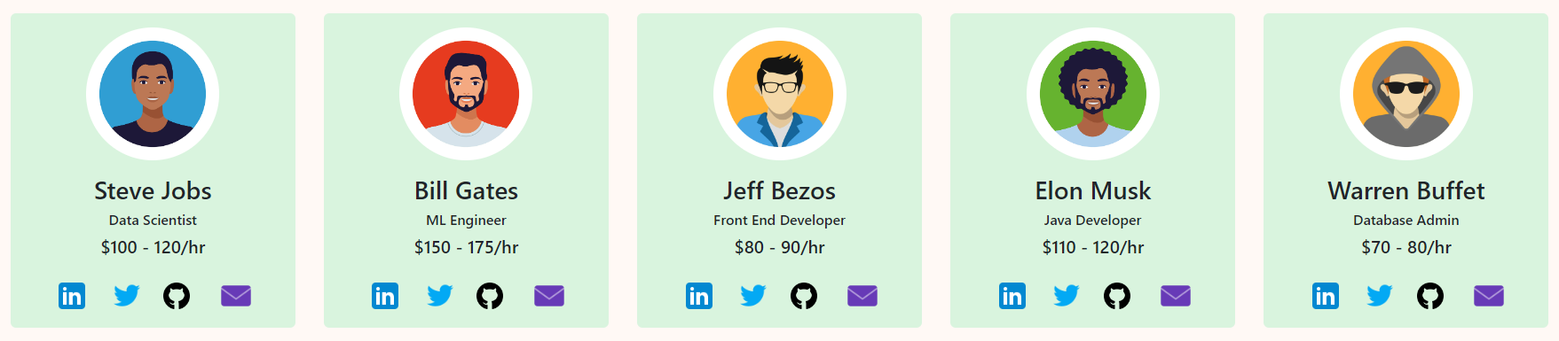

**Final Output:**

Once you have all the sections in place, you are now ready to put them all together in to one module. I normally call this a Content module, which ultimately gets called in the index.js file. However, you are most welcome to program it anyway you like as long as your code is organized and manageable. It is highly recommended though to keep separate modules inside a components folder. All of your images should go in the images folder inside the public directory.

Below is the final output of this assignment. You might notice headings between sections, e.g., **Hi, Jonathan** and **Trending Talents**, please use them to make your webpage look like the one shown below:

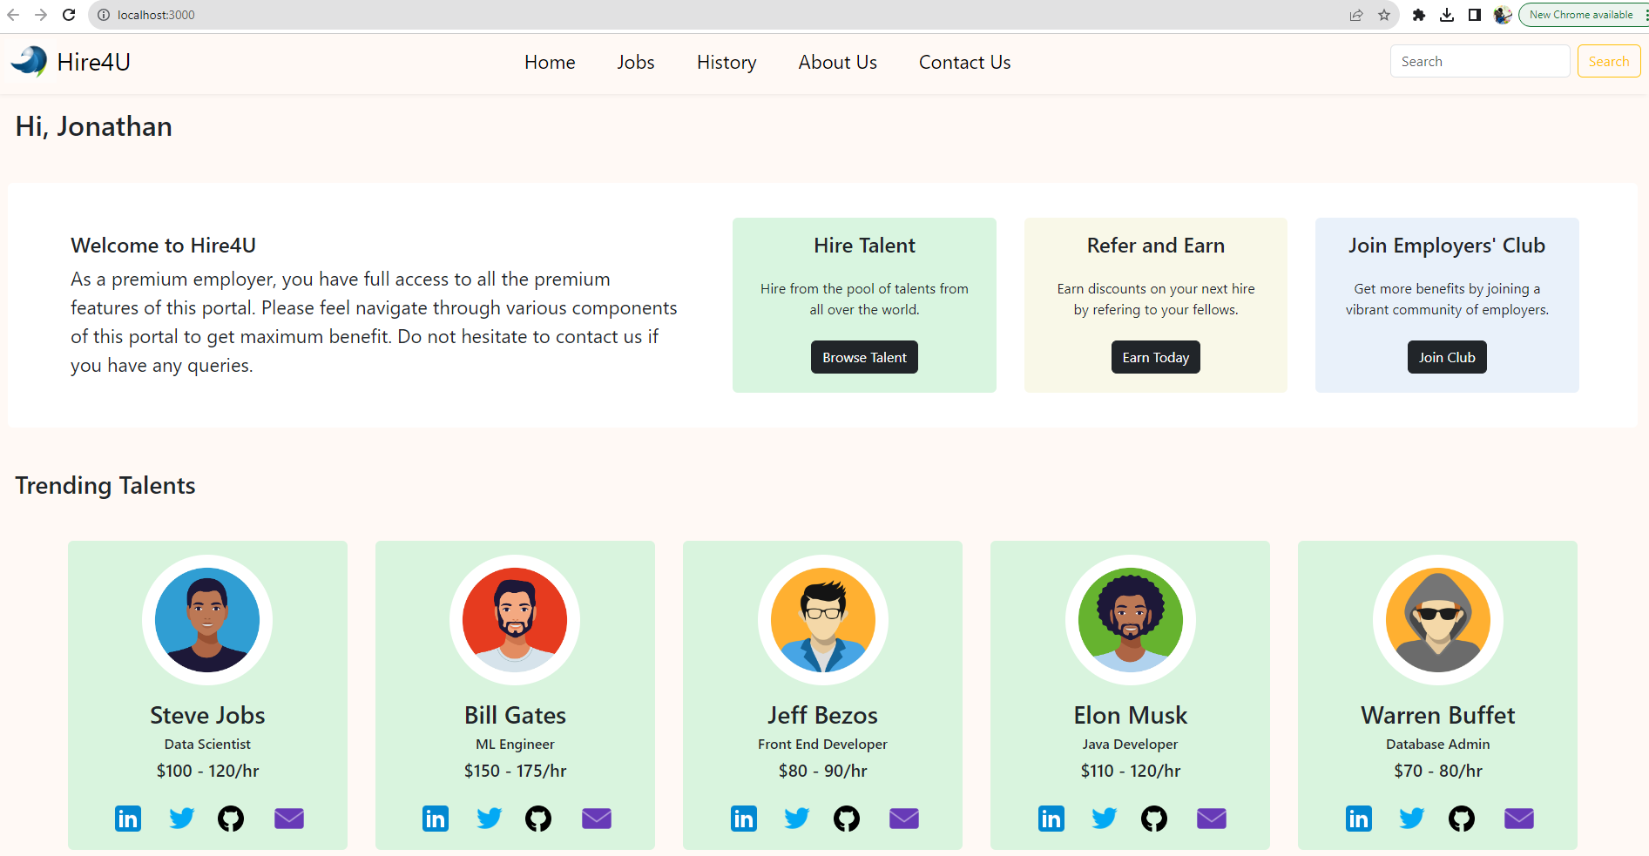

**Solution**

Start pasting your code here. Make sure to segregate your code by component names, e.g., NavBar.js.

Do not forget to provide the screenshot of the final output of your work.

Upload this word document as a submission.

**index.js**

import React from "react"

import ReactDOM from "react-dom"

import "bootstrap/dist/css/bootstrap.min.css"

import "./index.css"

import NavBar from "./components/NavBar"

import Welcome from "./components/Welcome"

import Talent from "./components/Talent"

ReactDOM.render(

    <div>

        <NavBar/>

        <Welcome userName="Jonathan"/>

        <Talent/>

    </div>,

    document.getElementById("root")

);

**NavBar.js**

import React from "react";

import "bootstrap/dist/css/bootstrap.min.css";

export default function NavBar() {

  return (

    <nav className="navbar navbar-expand-lg navbar-light">

        <div className="container-fluid ">

            <a className="navbar-brand" href="#">

                <img src="./images/logo.png" width={"50px"} alt="logo"/>

                Hire4U

            </a>

            <button className="navbar-toggler" type="button" data-bs-toggle="collapse" data-bs-target="#navbarSupportedContent" aria-controls="navbarSupportedContent" aria-expanded="false" aria-label="Toggle navigation">

                <span className="navbar-toggler-icon"></span>

            </button>

            <div className="collapse navbar-collapse" id="navbarSupportedContent">

                <div className="row mx-auto">

                <ul className="navbar-nav">

                    <li className="nav-item active mx-2">

                        <a className="nav-link" href="#">Home</a>

                    </li>

                    <li className="nav-item mx-2">

                        <a className="nav-link" href="#">Jobs</a>

                    </li>

                    <li className="nav-item mx-2">

                        <a className="nav-link" href="#">History</a>

                    </li>

                    <li className="nav-item mx-2">

                        <a className="nav-link" href="#">About Us</a>

                    </li>

                    <li className="nav-item mx-2">

                        <a className="nav-link" href="#">Contact Us</a>

                    </li>

                </ul>

                </div>

                <form className="d-flex form-inline" role="search">

                    <input className="form-control me-2" type="search" placeholder="Search" aria-label="Search" />

                    <button className="btn btn-outline-warning" type="submit">Search</button>

                </form>

            </div>

        </div>

    </nav>

  );

}

**Welcome.js**

import WelcomeCard from "./WelcomeCard"

export default function Welcome(props) {

    return (

      <div className="container-fluid py-4">

        <h2>Hi, {props.userName}</h2>

        <div className="card section">

          <div className="d-flex justify-content-between py-3 px-4">

            <WelcomeCard cardClass="card col-4 mx-2" title="Welcome to Hire4U" desc="As a premium employer, you have full access to all the premium features of this portal. Please feel navigate through various components of this portal to get maximum benefit. Do not hesitate to contact us if you have any queries."/>

            <WelcomeCard cardClass="card col mx-2 text-center bg-green" title="Hire Talent" desc="Hire from the pool of talents from all over the world." buttonClass="btn btn-dark" link="Browse Talent"/>

            <WelcomeCard cardClass="card col mx-2 text-center bg-yellow" title="Refer and Earn" desc="Earn discounts on your next hire by referring to your fellows." buttonClass="btn btn-dark" link="Earn Today"/>

            <WelcomeCard cardClass="card col mx-2 text-center bg-blue" title="Join Employer's Club" desc="Get more benefits by joining a vibrant community of employers." buttonClass="btn btn-dark" link="Join Club"/>

          </div>

        </div>

      </div>

    );

}

**WelcomeCard.js**

import React from "react";

import "bootstrap/dist/css/bootstrap.min.css";

export default function Welcome(props) {

  return (

    <div className={props.cardClass}>

        <div className="card-body align-items-center">

            <h5 className="card-title pb-2">{props.title}</h5>

            <p className="card-text pb-2">{props.desc}</p>

            <a href="#" className={props.buttonClass}>{props.link}</a>

        </div>

    </div>

  );

}

**Talent.js**

import TalentCard from "./TalentCard"

export default function Talent() {

    const names = ["Steve Jobs", "Bill Gates", "Jeff Bezos", "Elon Musk", "Warren Buffet"];

    const jobs = ["Data Scientist", "ML Engineer", "Front End Developer", "Java Developer", "Database Admin"];

    const rates = ["$100 - 120/hr", "$150 - 175/hr", "$80 - 90/hr", "$110 - 120/hr", "$70 - 80/hr"];

    const images = ["./images/1.jpg", "./images/2.jpg", "./images/3.jpg", "./images/4.jpg", "./images/5.jpg"];

    return (

      <div className="container-fluid py-4">

        <h3>Trending Talents</h3>

        <div className="section d-flex justify-content-around">

          {names.map((name, i) => {

            return <TalentCard key={i} imgSrc={images[i]} name={name} role={jobs[i]} pay={rates[i]}/>

          })}

        </div>

      </div>

    );

}

**TalentCard.js**

import React from "react";

import "bootstrap/dist/css/bootstrap.min.css";

export default function Talent(props) {

  return (

    <div className="card talent-card bg-green">

        <img className="card-img-top" src={props.imgSrc} alt="profileImg"/>

        <div className="card-body align-items-center text-center">

            <h5 className="card-title">{props.name}</h5>

            <p className="card-text role">{props.role}</p>

            <p className="card-text">{props.pay}</p>

        </div>

        <div className="d-flex justify-content-between">

            <a href="#"><img src="./images/linkedIn.png" alt="LinkedIn" /></a>

            <a href="#"><img src="./images/twitter.png" alt="Twitter" /></a>

            <a href="#"><img src="./images/github.png" alt="Github" /></a>

            <a href="#"><img src="./images/email.png" alt="Email" /></a>

        </div>

    </div>

  );

}

**index.css**

html, body {

  height: 100%;

}

body {

  background-color: #fdf7f1;

}

nav.navbar {

  border-bottom: 2px solid #eae9e5;

  padding: 0;

}

.nav-link {

  color: #000;

}

.section {

  margin-top: 2em;

}

.card {

  border: none;

}

.card.talent-card {

  width: 17em;

  padding: 20px 50px;

}

.talent-card .role {

  font-size: 12px;

}

.talent-card .card-img-top {

  border-radius: 50%;

  width: 10em;

  margin: 0 auto;

}

.talent-card h5,p {

  margin: 0;

  padding-bottom: .2em;

}

.talent-card > div img {

  width: 2em;

}

.talent-card a {

  display: block;

}

.bg-green {

  background-color: #c5f8c5;

}

.bg-yellow {

  background-color: #f6f6be;

}

.bg-blue {

  background-color: #c1ccf3;

}

**Final Outcome:**

